Abstract
This assignment is about getting hands-on practice with SQL using the Brewbean’s database in Oracle SQL Developer. The goal is to learn how to run database setup scripts, work with real tables, and write basic queries to pull and organize data. It also helps build familiarity with how relational databases are structured and how data is retrieved using SQL commands. After setting everything up, you complete the assigned questions from the textbook and document your queries and results clearly in a single submission.

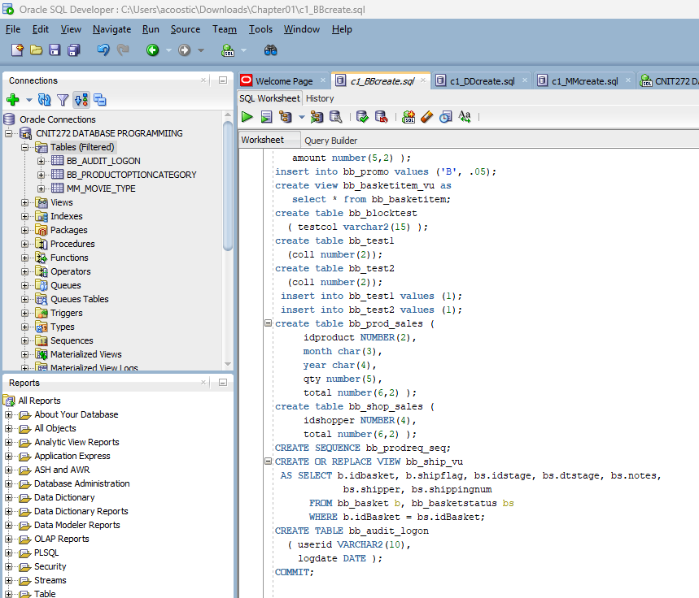
Confirming Table Schemas

This section fulfills the fundamental requirements outlined in the textbook for the c1_BBcreate.sql script. It demonstrates the creation and initialization of the basic database structure for the BB (Book Basket) system, including the essential tables, relationships, and constraints needed to support data integrity and proper relational design. The script establishes the foundation of the database by defining primary keys, foreign keys, and initial data inserts to ensure the system operates correctly and consistently.
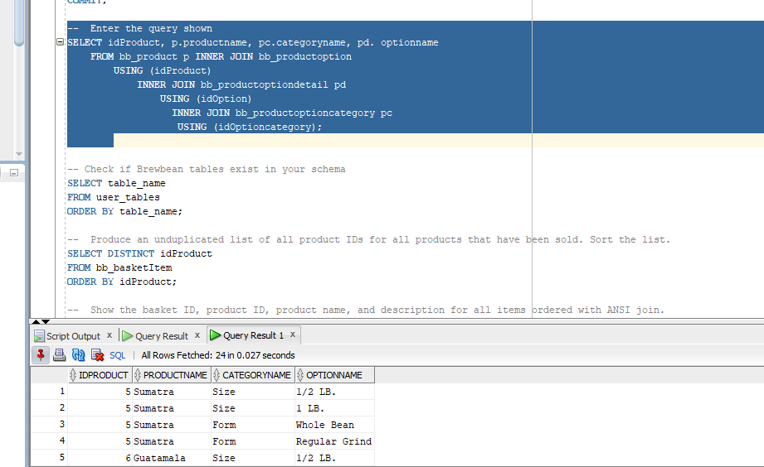
This screenshot displays the results of a SQL query that joins multiple related tables using INNER JOIN operations. The query retrieves product information along with associated product options and option categories from the database.
Specifically, the query combines the bb_product, bb_productoption, bb_productoptiondetail, and bb_productoptioncategory tables using shared key fields such as idProduct, idOption, and idOptionCategory. This allows the system to display detailed product configuration data in a single result set.
The output shows 24 total rows, confirming that the joins are working correctly and that all related product option combinations for idProduct 5 and idProduct 6 are being successfully retrieved. Each row includes the product ID, product name, category name, and option name, demonstrating proper relational data retrieval across multiple tables.

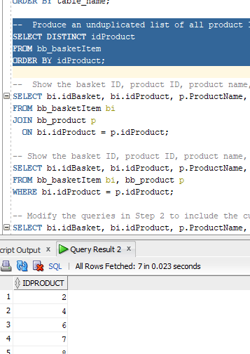
This query retrieves a unique list of all product IDs that have been sold in the database. It uses the DISTINCT keyword to eliminate duplicate entries, ensuring that each product ID appears only once in the result set. The data is pulled from the bb_basketItem table, which records individual product sales within customer baskets. The results are then sorted in ascending order by product ID to improve readability and make it easier to analyze which products have been sold.

This query retrieves all orders placed in February 2012 from the bb_basket table, displaying the basket ID, shopper ID, and date ordered, with the date formatted as "Month DD, YYYY" using the TO_CHAR function.
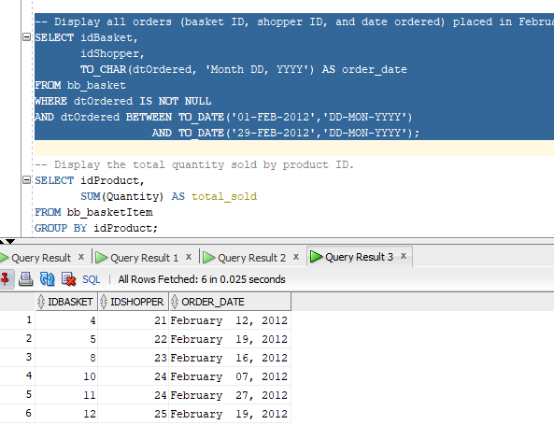

This query retrieves the total quantity sold for each product by using the SUM function on the quantity column and grouping the results by product ID from the bb_basketItem table.
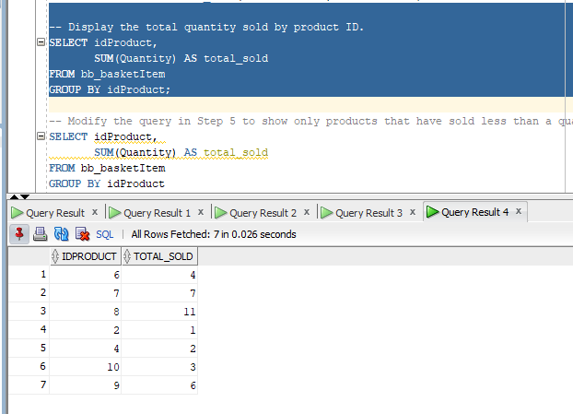

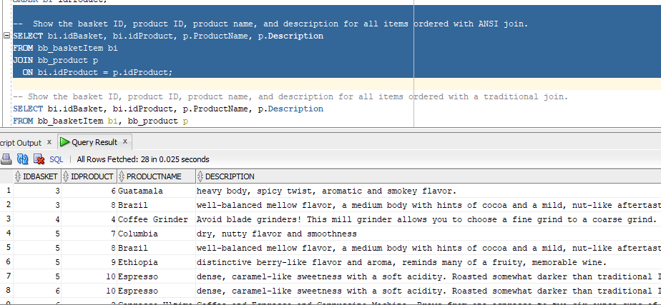
This query displays the basket ID, product ID, product name, and product description for all ordered items by joining the bb_basketItem and bb_product tables. It is written in two ways: using an ANSI JOIN and a traditional join. Both queries return the same results and demonstrate two valid methods of combining related tables in SQL.

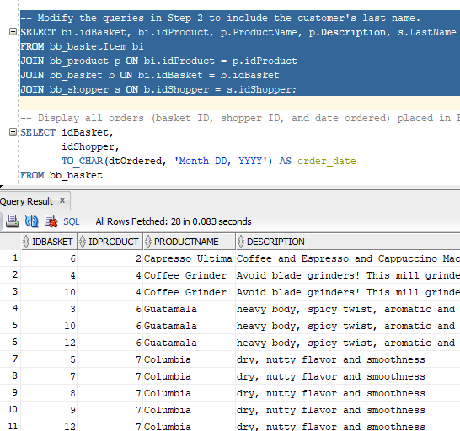
This query builds on the previous Step 2 queries by adding the customer's last name, joining the bb_basketItem, bb_product, bb_basket, and bb_shopper tables together to display the basket ID, product ID, product name, description, and shopper's last name in a single result set.

Step 1 & 2 — This SELECT query pulls all product information from the bb_product table and the results should match the listing shown in Figure 1-22.
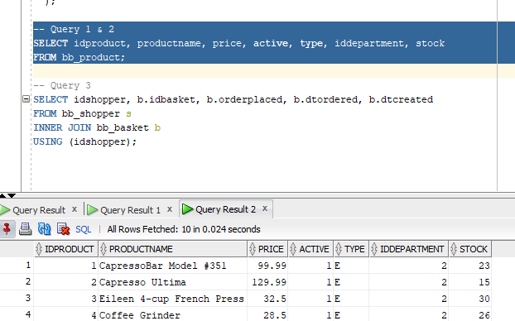
Step 3 - This query joins the bb_shopper and bb_basket tables together using the shared idshopper column to display order information, matching Figure 1-23.
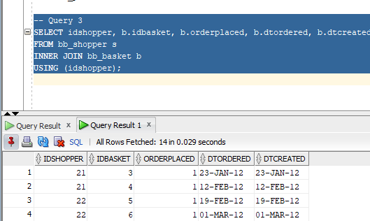

Moviemania Database Schema (c1_MMcreate.sql)
The c1_MMcreate.sql file defines the database schema for a movie rental system called Moviemania. This script creates the core structure of the database, including tables for members, movies, rentals, and payment methods. Each table is designed to store specific types of data needed to support the rental process, such as customer information, movie details, and transaction records.
In addition to creating tables, the script establishes primary keys and foreign key relationships to ensure data integrity across the database. These relationships link related records, such as connecting rentals to members and movies, allowing for accurate tracking of which customers rented which movies.
Overall, this SQL file provides the foundational structure required for the Moviemania system to operate efficiently and maintain organized, relational data.

Question 8 — This creates a new table called CONTACTS with 5 columns, each having specific rules like a primary key, not null, a default date, and a check constraint.
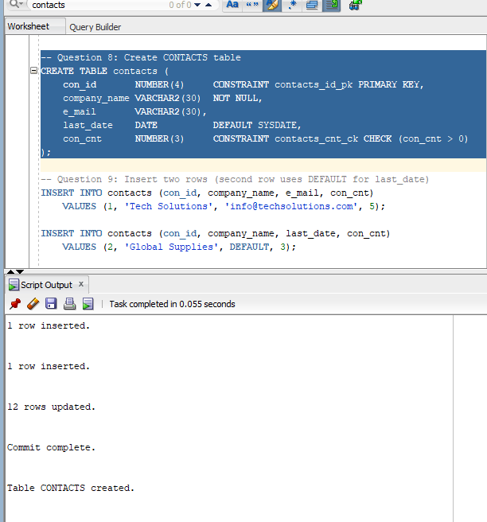
Question 9 – This command inserted two rows into the CONTACTS table, with the second row using the DEFAULT keyword to automatically fill in today's date, then COMMIT saves the data permanently.
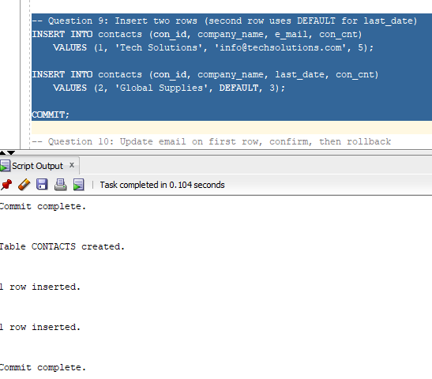
Question 10 - This updates the email on the first row, uses a SELECT to confirm the change was made, then ROLLBACK undoes it since it was never committed.
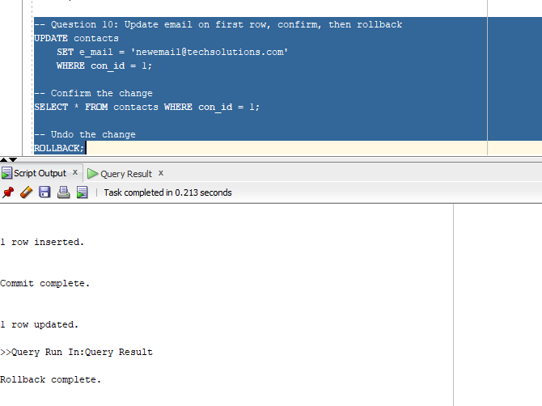

Assignment 1-2 — Third-Party PL/SQL Tool Review:
One popular third-party PL/SQL tool is Toad for Oracle by Quest Software. Two helpful features include:
- Code Editor with Auto-completion — Toad provides an intelligent code editor that suggests table names, column names, and PL/SQL syntax as you type, reducing errors and speeding up development.
- Schema Browser — This feature lets developers visually explore database objects like tables, indexes, and procedures without writing queries, making it easier to understand the database structure.

Assignment 1-3 — Brew bean's Checkout Logic Steps:
When the Check Out button is clicked, the following logical steps would need to occur:
- Retrieve all items currently in the customer's basket from the database
- Calculate the order subtotal by multiplying each item's price by its quantity and summing them
- Look up the shipping cost from the shipping table based on the total number of items in the order
- Identify the customer's billing state from their account information
- Look up the tax percentage from the tax table based on the billing state
- Calculate the tax amount by applying the tax percentage to the order subtotal
- Calculate the final total by adding the subtotal + shipping + tax
- Display the subtotal, shipping amount, tax amount, and final total on the next page

Additional References

-- Check if Brewbean tables exist in your schema
SELECT table_name
FROM user_tables
ORDER BY table_name;

-- Produce an unduplicated list of all product IDs for all products that have been sold. Sort the list.
SELECT DISTINCT idProduct
FROM bb_basketItem
ORDER BY idProduct;

-- Show the basket ID, product ID, product name, and description for all items ordered with ANSI join.
SELECT bi.idBasket, bi.idProduct, p.ProductName, p.Description
FROM bb_basketItem bi
JOIN bb_product p
ON bi.idProduct = p.idProduct;

-- Show the basket ID, product ID, product name, and description for all items ordered with a traditional join.
SELECT bi.idBasket, bi.idProduct, p.ProductName, p.Description
FROM bb_basketItem bi, bb_product p
WHERE bi.idProduct = p.idProduct;

-- Modify the queries in Step 2 to include the customer's last name.
SELECT bi.idBasket, bi.idProduct, p.ProductName, p.Description, s.LastName
FROM bb_basketItem bi
JOIN bb_product p ON bi.idProduct = p.idProduct
JOIN bb_basket b ON bi.idBasket = b.idBasket
JOIN bb_shopper s ON b.idShopper = s.idShopper;

-- Display all orders (basket ID, shopper ID, and date ordered) placed in February 2012. The date should be displayed in this format: February 12, 2012.
SELECT idBasket,
idShopper,
TO_CHAR(dtOrdered, 'Month DD, YYYY') AS order_date
FROM bb_basket
WHERE dtOrdered IS NOT NULL
AND dtOrdered BETWEEN TO_DATE('01-FEB-2012','DD-MON-YYYY')
AND TO_DATE('29-FEB-2012','DD-MON-YYYY');

-- Display the total quantity sold by product ID.
SELECT idProduct,
SUM(Quantity) AS total_sold
FROM bb_basketItem
GROUP BY idProduct;

-- Modify the query in Step 5 to show only products that have sold less than a quantity of 3.
SELECT idProduct,
SUM(Quantity) AS total_sold
FROM bb_basketItem
GROUP BY idProduct
HAVING SUM(Quantity) < 3
ORDER BY idProduct;

-- List all active coffee products (product ID, name, and price) for all coffee items priced above the overall average of coffee items.
SELECT idProduct, ProductName, Price
FROM bb_product
WHERE Active = 1
AND Type = 'C'
AND Price > (
SELECT AVG(Price)
FROM bb_product
WHERE Type = 'C'
);

-- Query 1 & 2
SELECT idproduct, productname, price, active, type, iddepartment, stock
FROM bb_product;

-- Query 3
SELECT idshopper, b.idbasket, b.orderplaced, b.dtordered, b.dtcreated
FROM bb_shopper s
INNER JOIN bb_basket b
USING (idshopper);

